**Test Summary Report**

**by Mariia Mielnikova**

**based on**

**E2E testing and User Stories**

**by Max Shylov**

*Review Date: 09.02.2024*

*Project name: SKYBOT*

**Step #1) Purpose of the document**

This document explains a summary report based on E2E testing scenarios and User Stories performed as part of the Testing process of the “SKYBOT”

**Step #2) “SKYBOT” Overview**

B2C portal for a company that sells and services electric vehicles under the brand name SKYBOT. Also, potential users could register on the portal and communicate with other Members. Every registered User will have personal profile and could manage it with different options

Link to the portal - <https://prometheusqastage3.wixsite.com/skybot>

**Step #3) Testing Scope**

A functionality verification of this webportal will be presented by different kinds of testing scenarios, User Stories and test cases, which were created earlier and will show full coverage of the main function and its possibilities.

Areas covered:

* Navigation
* Ordering
* Payment
* Exploring
* Review

Areas not covered:

* Registration
* Log in
* Profile functions
* Action with videos

**Step #4) Test summary**

* **Website Navigation**

Navigation tests confirm that Users will not have any difficulties during navigation through the SKYBOT portal. Instructions are clear and simple. All elements are open without delays and errors.

* **Buying Goods**

This section presented the opportunity to buy some products and leave reviews. Each step of the test case is executed in accordance with its description and according to the logic.

* **Chat Window**

The function of communication with the store staff is presented in the form of test cases based on the Chat Box. Practically all test covered possibilities of this function.

* **Cart Functionality**

To achieve this goal, most of the necessary tests were performed to confirm the functionality of the main elements of the Shopping Cart section.

* **Test-Drive Registration**

All possible tests were performed on this tab. Test cases are write in a detailed and logical manner.

**Step #5) Metrics**

| **Tests performed** | **Tests passed** | **Tests failed** |
| --- | --- | --- |
| **26** | **16** | **10** |

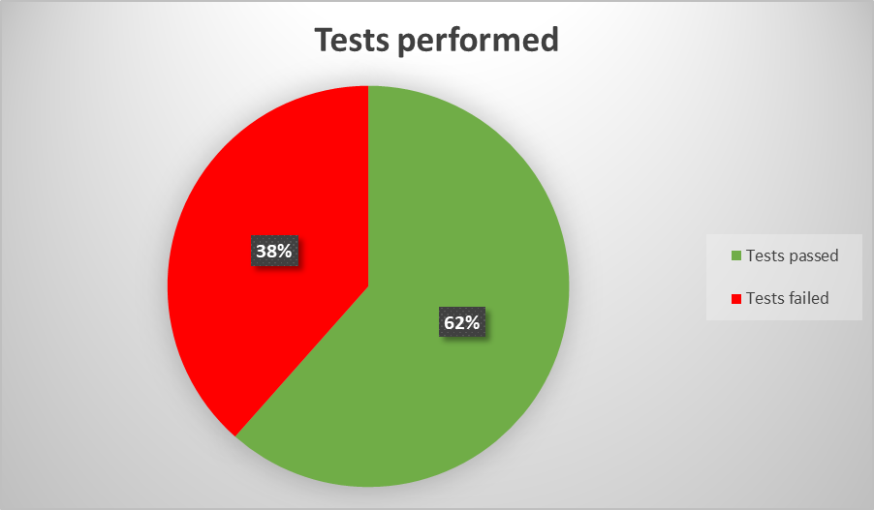

**Step #6) Environment**

*Windows 10 Pro, Google Chrome 119.0.6045.160*

**Step #7) Recommendations**

* **I recommend to include in future tests - testing of user registration and logging. This is a very important and basic function of our portal.**
* **Additionally, one of the important suggestions I can make is to test the user profile and interaction with it and its functions**
* **Good practice also will be testing actions with video in the section “Video reviews”**

**Step #8) Exit criteria**

* All test cases that were planned are executed successfully
* All critical issues are closed
* Any other open issues have an action planned and are targeted for the next release cycle.

**Step #9) Conclusion**

*The portal was tested at a high level, which is confirmed by E2E tests and written User Stories. It is recommended that some sections and details be finalized. Appropriate User/Business acceptance testing should be performed before ‘Go Live’.*

**Step #10) Sign Off**

***Verified by Mariia Mielnikova***